
Faculty of Science

Course: CSCI 2020u – Software System Development & Integration
Component: Assignment
Weight: 10%
Deadline: March 6, 2019 (due by 11:59pm)

Collaboration Policy
You are permitted to work on this assignment in a team, and submit the results as a team. For this sort of assignment, with an open-ended component, the collaboration between multiple team members can be beneficial. Between groups, however, please limit the discussion to the level of general strategy (not code). Groups of size 2 are recommended. Larger groups will be considered with the proviso that the marker will mark your assignment with higher expectations. In any case, be sure that all members of the team fully understand all code, otherwise they will miss intended learning objectives, which may be a considerable disadvantage at exam time.

How to Submit
You will maintain a git repository for this assignment, which is a public repository. To submit the assignment, create a single file ‘README.txt’ that contains instructions on how to download, compile, and run your codes for each question. A .zip, .7z, or .rar file will not be acceptable. Also submit this word file (once you complete) into related drop box on Blackboard before deadline.

Note: Comments are mandatory. Failure to properly document your program will result in a deduction on the marks you receive for this (and any other) assignment.

Remember:
You need to complete this file and submit it in related drop box on Blackboard, in addition to uploading your codes in your git repository, before deadline.

Question 1: Displaying Three Cards

Problem Description:
Display a frame that contains three labels. Each label displays a card, as shown in the figure below. The card image files are named 1.png, 2.png, ..., 54.png and stored in the image/card directory. All three cards are distinct and selected randomly.

The image icons can be found in the attached card folder.

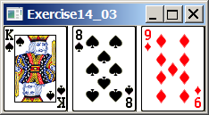

Your Task:
- Create three ImageView and set their icons using the images.
- Display three images from 54 image cards randomly.

Your Code:
/*James LeBlanc : 100663391
* Question number one of assignment one for CSCI-2020U
*
* This program takes 3 random pictures of cards from the
* filename given and adds them to the screen
*/

package assignment_01;

import java.util.Random;
import javafx.application.Application;
import javafx.scene.Scene;
import javafx.scene.control.Label;
import javafx.scene.image.ImageView;
import javafx.scene.layout.GridPane;
import javafx.stage.Stage;

public class Question_01 extends Application{

public static void main(String[] args) {
launch(args);
}

@Override
public void start(Stage primaryStage) throws Exception {

Random rand = new Random();
//the FOLDER where all the different card png's are
//change the string to whatever directory you have the folder
String fileName = "file:///C:/Users/User/Desktop/Assignment/Cards";

//the number of cards to be printed to the screen
//this allows the program to be modifiable
int numCards = 3;
if(numCards > 54) numCards = 54;
int[] cards = new int[numCards];
int check = 0;

//loops until three separate random cards are
//chosen from the 54 available
while(cards[numCards-1] == 0) {
int num = rand.nextInt(54) + 1;
boolean ok = true;

for(int y = 0; y < check; y++) {
if(num == cards[y]) {
ok = false;
break;
}
}
if(ok) {
cards[check] = num;
check++;
}
}

GridPane pane = new GridPane();

//takes the cards chosen and adds them to the gridpane
for(int x = 0; x < numCards; x++) {
Label card = new Label("",new ImageView(fileName + "/" + cards[x] + ".png"));
pane.add(card,x,0);
}

Scene scene = new Scene(pane,numCards*72,96);
primaryStage.setTitle("Question 01"); // Set the stage title
primaryStage.setScene(scene); // Place the scene in the stage
primaryStage.show(); // Display the stage

}

}

Screen shots:
Include two screen shots here:

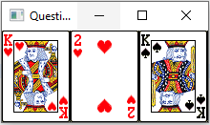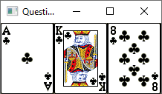

Question 2: Investment-Value calculator

Problem Description:
Write a program that calculates the future value of an investment at a given interest rate for a specified number of years. The formula for the calculation is as follows:

futureValue = investmentAmount * (1 + monthlyInterestRate)years*12

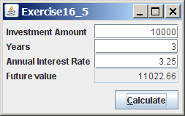

Your Task:
Use text fields for interest rate, investment amount, and years. Display the future amount in a text field when the user clicks the Calculate button, as shown in the figure.

Your Code:
/* James LeBlanc : 100663391
* Question number two of assignment one for CSCI-2020U
*
* This program takes displays a pane and allow the user
* to enter in three values; investment amount, years,
* and annual interest rate, and then this program will then
* calculate and display the Future Value
*/

package assignment_01;

import javafx.application.Application;
import javafx.event.ActionEvent;
import javafx.event.EventHandler;
import javafx.geometry.Insets;
import javafx.geometry.Pos;
import javafx.scene.Scene;
import javafx.scene.control.Button;
import javafx.scene.control.Label;
import javafx.scene.control.TextField;
import javafx.scene.layout.BorderPane;
import javafx.scene.layout.GridPane;
import javafx.stage.Stage;

public class Question_02 extends Application{

public static void main(String[] args) {
launch(args);
}

@Override
public void start(Stage primaryStage) throws Exception {

//setting up panes for the display
BorderPane pane = new BorderPane();
pane.setPadding(new Insets(10,10,10,10));
GridPane gp = new GridPane();
gp.setPadding(new Insets(0,0,10,0));
gp.setHgap(5);

//setting up different labels for later use
Label[] labels = new Label[4];
labels[0] = new Label("Investment Amount");
labels[1] = new Label("Years");
labels[2] = new Label("Annual Intrest Rate");
labels[3] = new Label("Future Value");
gp.addColumn(0, labels);

//sets up all of the different text fields for the
//user to use
TextField[] text = new TextField[4];
for(int x = 0; x < 4; x++) {
text[x] = new TextField("");
text[x].setAlignment(Pos.CENTER_RIGHT);
}
text[3].setEditable(false);
gp.addColumn(1, text);

Button btn = new Button("Calculate");
btn.setDefaultButton(true);

//main functionality:
//when pressed this takes all of the different
//numbers entered by the user and calculates the future value
btn.setOnAction(new EventHandler<ActionEvent>() {

@Override
public void handle(ActionEvent e) {
double IA = Double.parseDouble(text[0].getText());
double years = Double.parseDouble(text[1].getText());
double MIR = Double.parseDouble(text[2].getText()) / (12.0*100);

text[3].setText(Double.toString(IA * Math.pow(1+MIR,years*12.0)));
}

});

pane.setTop(gp);
pane.setRight(btn);

Scene scene = new Scene(pane,280,150);
primaryStage.setTitle("Question 02"); // Set the stage title
primaryStage.setScene(scene); // Place the scene in the stage
primaryStage.show(); // Display the stage

}

}
Screen shots:
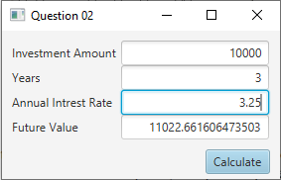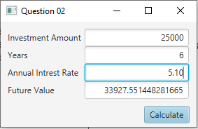

Question 3: Dragging Points on a Circle

Problem Description:
Draw a circle with three random points on the circle. Connect the points to form a triangle. Display the angles in the triangle. Use the mouse to drag a point along the perimeter of the circle. As you drag it, the triangle and angles are redisplayed dynamically.

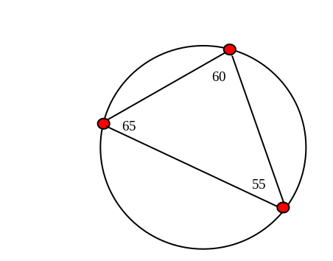

Here is the formula to compute angles:

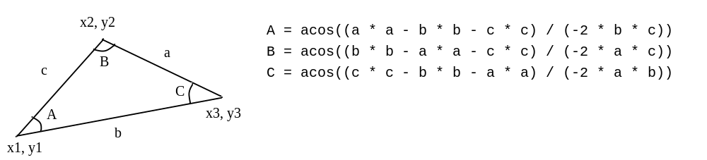

Your Code:
/* James LeBlanc : 100663391
* Question number three of assignment one for CSCI-2020U
*
* This program allows the user to play around with three
* Separate points, rotating around a triangle
* The user can move any of the points, and the
* triangle will update in real time, as well as displaying
* each angle of the triangle
*/

package assignment_01;

import java.util.Random;
import java.lang.Math;

import javafx.application.Application;
import javafx.scene.Scene;
import javafx.scene.layout.Pane;
import javafx.scene.paint.Color;
import javafx.scene.shape.Circle;
import javafx.scene.shape.Line;
import javafx.scene.text.Text;
import javafx.stage.Stage;

public class Question_03 extends Application{

public static void main(String[] args) {
launch(args);
}

@Override
public void start(Stage primaryStage) throws Exception {

Pane pane = new Pane();
Random rand = new Random();

//The circle used as the structure for the triangle
//is static throughout the entire runtime
Circle circ = new Circle(200,200,150);
circ.setFill(null);
circ.setStroke(Color.BLACK);

//the points on the circle
Circle[] points = new Circle[3];
//this displays each angle of the triangle
Text[] texts = new Text[3];

//This sets up the original image that the user sees
//when they start the program
for(int x = 0; x < 3; x++) {
double angle = Math.toRadians(rand.nextInt(361));

if(angle < 90 && angle > 270)
texts[x] = new Text(200 + 180*Math.cos(angle), 200 + 170*Math.sin(angle),"");
else
texts[x] = new Text(200 + 160*Math.cos(angle), 200 + 170*Math.sin(angle),"");

points[x] = new Circle(200 + 150*Math.cos(angle), 200 + 150*Math.sin(angle), 5);
points[x].setFill(Color.RED);
points[x].setStroke(Color.BLACK);
}

double[] angles = new double[3];
Line[] lines = new Line[3];

calculate(points, angles, texts, lines);

//each of these control each point of the triangle
//and is what allows the triangle to change
points[0].setOnMouseDragged(e -> {
double X = e.getX()-200.0;
double Y = e.getY()-200.0;
double angle = Math.atan(Y/X);
movePoint(0,points,texts,angle,X);
calculate(points, angles, texts, lines);
});
points[1].setOnMouseDragged(e -> {
double X = e.getX()-200.0;
double Y = e.getY()-200.0;
double angle = Math.atan(Y/X);
movePoint(1,points,texts,angle,X);
calculate(points, angles, texts, lines);
});
points[2].setOnMouseDragged(e -> {
double X = e.getX()-200.0;
double Y = e.getY()-200.0;
double angle = Math.atan(Y/X);
movePoint(2,points,texts,angle,X);
calculate(points, angles, texts, lines);
});

pane.getChildren().add(circ);
pane.getChildren().addAll(lines);
pane.getChildren().addAll(points);
pane.getChildren().addAll(texts);

Scene scene = new Scene(pane,400,400);
primaryStage.setTitle("Question 03"); // Set the stage title
primaryStage.setScene(scene); // Place the scene in the stage
primaryStage.show(); // Display the stage
}

//This function handles the movement of the point passed, and allows the
//point to move smoothly around the circle
public void movePoint(int point, Circle[] points, Text[] texts, double angle, double X) {
if(X >= 0) {
points[point].setCenterX(200 + 150*Math.cos(angle));
points[point].setCenterY(200 + 150*Math.sin(angle));
texts[point].setX(200 + 160*Math.cos(angle));
texts[point].setY(200 + 170*Math.sin(angle));
}else {
points[point].setCenterX(200 - 150*Math.cos(angle));
points[point].setCenterY(200 - 150*Math.sin(angle));
texts[point].setX(200 - 180*Math.cos(angle));
texts[point].setY(200 - 170*Math.sin(angle));
}
}

//This function does the mathematical calculations for the program; things like the
//lines and angles of the Triangle.
//after calculation, it then updates the arrays given with the new values
public void calculate(Circle[] points, double[] angles, Text[] texts, Line[] lines) {
//made an array of all of the different positions of the points, so you don't have
//to look them up every time
//1st number is the point you wish to look up
//2nd number is if you want x or y, 0 = x, and 1 = y
double xyPos[][] = {{points[0].getCenterX(), points[0].getCenterY()},
{points[1].getCenterX(), points[1].getCenterY()},
{points[2].getCenterX(), points[2].getCenterY()}};

//this creates the lines of the triangle if they are not already made
//and if they are this simply updates them
if(lines[0] == null) {
lines[0] = new Line(xyPos[0][0], xyPos[0][1], xyPos[1][0], xyPos[1][1]);
lines[1] = new Line(xyPos[1][0], xyPos[1][1], xyPos[2][0], xyPos[2][1]);
lines[2] = new Line(xyPos[2][0], xyPos[2][1], xyPos[0][0], xyPos[0][1]);
}else {
lines[0].setStartX(xyPos[0][0]); lines[0].setStartY(xyPos[0][1]);
lines[0].setEndX(xyPos[1][0]); lines[0].setEndY(xyPos[1][1]);
lines[1].setStartX(xyPos[1][0]); lines[1].setStartY(xyPos[1][1]);
lines[1].setEndX(xyPos[2][0]); lines[1].setEndY(xyPos[2][1]);
lines[2].setStartX(xyPos[2][0]); lines[2].setStartY(xyPos[2][1]);
lines[2].setEndX(xyPos[0][0]); lines[2].setEndY(xyPos[0][1]);
}

//by using pythagorean theorem, the program calculates the length of each line
double a = Math.sqrt(Math.pow(Math.abs(xyPos[1][0] - xyPos[2][0]), 2) +
Math.pow(Math.abs(xyPos[1][1] - xyPos[2][1]), 2));
double b = Math.sqrt(Math.pow(Math.abs(xyPos[2][0] - xyPos[0][0]), 2) +
Math.pow(Math.abs(xyPos[2][1] - xyPos[0][1]), 2));
double c = Math.sqrt(Math.pow(Math.abs(xyPos[0][0] - xyPos[1][0]), 2) +
Math.pow(Math.abs(xyPos[0][1] - xyPos[1][1]), 2));

//uses cosine law to calculate each of the angles for the triangle
angles[0] = Math.acos((a*a - b*b - c*c) / (-2 * b * c));
angles[1] = Math.acos((b*b - a*a - c*c) / (-2 * a * c));
angles[2] = Math.acos((c*c - a*a - b*b) / (-2 * a * b));

//updates the text to show the new angles of the triangle
for(int x = 0; x < 3; x++)
texts[x].setText(Double.toString(Math.round(Math.toDegrees(angles[x])*100.0)/100.0));
}

}
Screen shots:
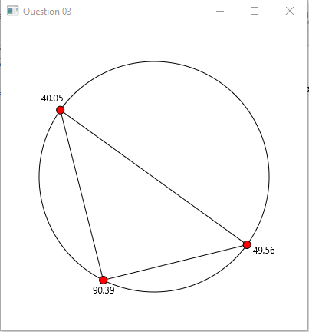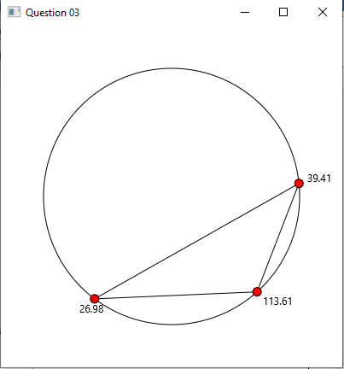
Question 4: Histogram

Problem Description:
Develop a program that displays a histogram to show the occurrences of each letter in a text area. The histogram should show the occurrences of each letter in a text file, as shown in the following figure. Assume that the letters are not case sensitive.

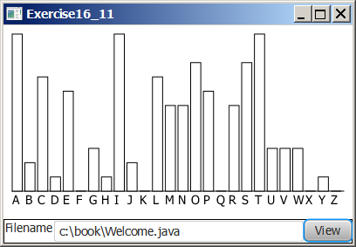

Your Task:
- Place a pane that will display the histogram in the center of the frame.
- Place a label and a text field in a panel, and put the panel in the south side of the frame. The text file will be entered from this text field.
- Pressing the Enter key on the text field causes the program to count the occurrences of each letter and display the count in a histogram.

Your Code:
/* James LeBlanc : 100663391
* Question number four of assignment one for CSCI-2020U
*
* This program displays a histogram of all of the different
* letters in a file given by the user
*/

package assignment_01;

import java.io.*;
import java.util.Scanner;

import javafx.application.Application;
import javafx.event.ActionEvent;
import javafx.event.EventHandler;
import javafx.geometry.Insets;
import javafx.scene.Scene;
import javafx.scene.control.Button;
import javafx.scene.control.TextField;
import javafx.scene.layout.BorderPane;
import javafx.scene.layout.HBox;
import javafx.scene.layout.Pane;
import javafx.scene.paint.Color;
import javafx.scene.shape.Line;
import javafx.scene.shape.Rectangle;
import javafx.scene.text.Text;
import javafx.stage.FileChooser;
import javafx.stage.Stage;

public class Question_04 extends Application{

private final String[] Alphabet = {"A","B","C","D","E","F","G","H","I","J","K","L","M",
"N","O","P","Q","R","S","T","U","V","W","X","Y","Z"};

public static void main(String[] args) {
launch(args);
}

@Override
public void start(Stage primaryStage) throws Exception {
//setting up initial panes
BorderPane pane = new BorderPane();
pane.setPadding(new Insets(10,10,10,10));
HBox box = new HBox();
Pane pn = new Pane();

//width and height that will be used for the bars of the graph
int width = 10; int height = 200;

//alpha count = amount of each letter
int[] alphaCount = new int[26];
//letters = A,B,C...., used for display on histogram
Text[] letters = new Text[26];
for(int i = 0; i < 26; i++) {
letters[i] = new Text((width+5)*i,height+10, Alphabet[i]);
alphaCount[i] = 0;
}

//bars = bars of the histogram
Rectangle[] bars = makeBars(alphaCount, height, width);

//setting up the pieces need for the user input
TextField fileSelect = new TextField();
fileSelect.setPrefColumnCount(25);
Button sel = new Button("select");
Button load = new Button("Load");
load.setDefaultButton(true);
box.getChildren().addAll(fileSelect, sel, load);

//when select is pressed, the program will bring up a file select screen,
//allowing the user to navigate through their files and select one of their
//choice
//The file path is then placed into the text field, allowing the user
//to load that file chosen
sel.setOnAction(new EventHandler<ActionEvent>(){

public void handle(ActionEvent arg0) {
FileChooser fileChooser = new FileChooser();
fileChooser.setInitialDirectory(new File(System.getProperty("user.home")));
FileChooser.ExtensionFilter extFilter = new FileChooser.ExtensionFilter("TXT files (*.txt)", "*.txt");
fileChooser.getExtensionFilters().add(extFilter);
File file = fileChooser.showOpenDialog(primaryStage);
if(file != null)
fileSelect.setText(file.getAbsolutePath());
}

});

//When load is pressed, the text in the text field is tested to see
//if what is given is actually a path to a text file or not
//if it is, then methods will be called, allowing the histogram
//to update, displaying the letter count for the file
load.setOnAction(new EventHandler<ActionEvent>() {

public void handle(ActionEvent arg0) {
File file = new File(fileSelect.getText());
if(file.exists()) {
try {
Rectangle[] temp = makeBars(countLetters(file), height, width);
for(int i = 0; i < 26; i++) {
bars[i].setX(temp[i].getX());
bars[i].setY(temp[i].getY());
bars[i].setWidth(temp[i].getWidth());
bars[i].setHeight(temp[i].getHeight());
}

} catch (FileNotFoundException e) {
e.printStackTrace();
}
}
}

});

pn.getChildren().addAll(bars);
pn.getChildren().addAll(letters);
pn.getChildren().add(new Line(0,height,(width+5)*26,height));

pane.setTop(pn);
pane.setRight(box);

Scene scene = new Scene(pane,(width+5)*26 + 20, height+60);
primaryStage.setTitle("Question 04"); // Set the stage title
primaryStage.setScene(scene); // Place the scene in the stage
primaryStage.show(); // Display the stage
}

//This method reads in the file given line by line
//and counts the different letters inside it, it then return
//the final tally
private int[] countLetters(File file) throws FileNotFoundException {
Scanner input = new Scanner(file);
int[] letters = new int[26];

while(input.hasNext()) {
String line = input.nextLine();
for(int x = 0; x < line.length(); x++) {
char letter = line.charAt(x);
for(int y = 0; y < 26; y++) {
if((int)letter == 65+y || (int)letter == 97+y) {
letters[y]++;
break;
}
}
}
}
input.close();

return letters;
}

//This function makes the bars of the histogram and returns the bars
//created
private Rectangle[] makeBars(int[] alphaCount, int height, int width) {
Rectangle[] bars = new Rectangle[26];

double max = 0;
for(int i:alphaCount) {
if(i > max) max = i;
}

for(int i = 0; i < 26; i++) {
double indHeight = (height-10)*((double)alphaCount[i]/max);
bars[i] = new Rectangle(15*i,height-indHeight,width,indHeight);
bars[i].setFill(Color.WHITE);
bars[i].setStroke(Color.BLACK);
}

return bars;
}

}
Screen shots:
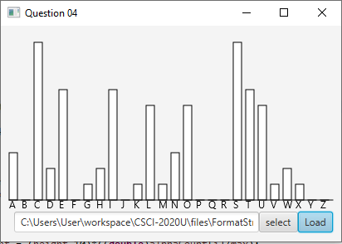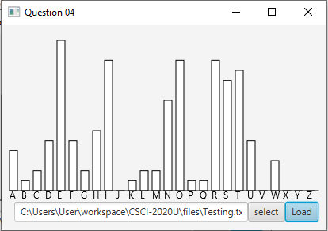
Remember:

You need to complete this file and submit it in related drop box on Blackboard, in addition to uploading your codes in your git repository, before deadline.

